Friendship Through Scales Spring 2003
© By the Northern Midwest ZNA Reprints only with the written permission of the NMZNA

Northern Midwest ZNA Newsletter 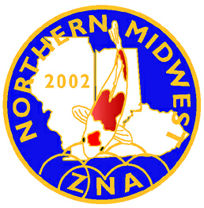
Inside this Issue:
- Eulogy about Millie Brudd
by Bob Brudd

- Farewell Dear Friend…

- Treasured Memories
By Debbie Leschuck

- Robin Passavoy
By Millie Brudd

- Eulogy about Dr. Luroki
by Jim Reilly

In memory of Millie
By: Bob Brudd

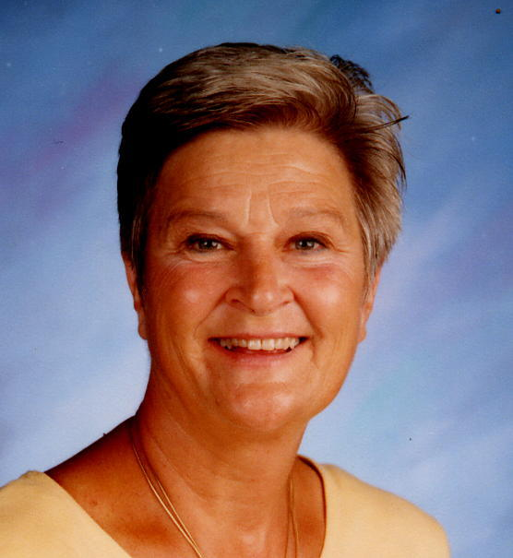

Dear Friends,

Thank you for coming to celebrate the exquisitely wonderful life of the most special human being I have ever known and will ever know. Were the cosmos solid and not vacuous, it would not be big enough to fill the hole in our hearts. Her loss to family, friends, colleagues and students is immeasurable. She was a woman who loved many things about life and she actively pursued all of them.

She especially loved those of us who were her family, especially her two grandbabies, Karah and Allison. Just last weekend she shared the coloring of Easter eggs and opening of Easter baskets with each of them. Luckily, I was enlisted to photograph each of the girls as they celebrated the day, and those images will forever be a legacy to her love of preparing special gift baskets as an expression of the love that she felt for everyone who was ever fortunate enough to be the recipient of one. One of the special moments of the day was her explaining to Allison, who doesn’t like being photographed, the special meaning of treasured pictures. As she cuddled her closely, Mil went through an album of family photos pointing out Great-grandma Dujmovich and Great-aunt Judy, and explaining that pictures help us remember those who’ve passed on before us. How prophetic.

She loved her children, Michael and Laura, and their significant others, Amanda and Greg. She was both proud of their accomplishments and proud that they were her children. She looked at Mike and Laura as her living legacy, an extension of herself who would carry on the family’s traditions. She was also proud of the different paths that they each chose to follow: Laura’s passion and pursuit of medicine, and Michael’s love of automobiles and working with people at Apple Chevrolet.

She loved teaching and the people you meet along the way – students, colleagues and Vipers. She was passionate about the written word, and given the chance, could probably have taught an ape to be literate. Like any great teacher, she was passionate about her students, and they were passionate about her. We couldn’t go anywhere without bumping into former students who would light up at the sight of her. She worked hard to help students get into great schools where they could pursue their own dreams, and when they needed her years later for counsel or an additional letter of recommendation, she was there for them.

She proudly carried the title of “Viper” and loved her fellow serpents with an indelible loyalty. It broke her heart when “conditions” in the building she’d grown to love drove her away from the classes and friends with whom she'd hoped to "graduate" as she retired from a career of service to others.

She loved green growing things and koifish with sparkling scales, and she was ever so grateful for this year’s early spring. Tuesday evening, when I returned from babysitting one of our granddaughters, she proudly showed off her latest edged flowerbed and had difficulty containing her joy and pride. No matter how hot the summer, she was out in her yard, attired in shorts, tank top, gloves, and bandanna, a trowel and five gallon bucket always near. She insisted on carrying the heavy bags of garden waste to the curb herself and would only ask for help when they weighed more than she. In summer, there were flowers, hanging baskets, potted plants, and all manner of growing things everywhere – literally. Green things and transforming bad dirt into good dirt were a passion.

She loved clothes and shoes and bright pink flamingos and had a collection of each that would have made Imelda Marcos pale. Bright and flashy was her thing. Subdued was for the timid.

She loved our friends and there was no one more loyal to a friend than Millie. When she took you into her heart, you stayed there forever. You might try to break away, but she’d always hold on to you tightly. If you needed her, she was there, and even when you said you didn’t need her, she was there. She was always there.

Finally, for some unknown and undefinable reason, she loved me. Our favorite plays were Hamlet and Antigone. In our shared life, I was the inward, contemplative Hamlet, and she was the fiercely loyal and principled Antigone.

In many ways we were opposites, yet we fit together like the fish in the Taoist ying yang symbol. In essence, we were complements to each other’s strengths and weaknesses. Until now, I’ve had her at my side to help keep me whole. Now I will have to rely on memory to take her place, which will be no easy task,

Ironically, my wonderful wife, who had a huge and embracing heart, was done in by the very organ that made her so beloved to all of us.

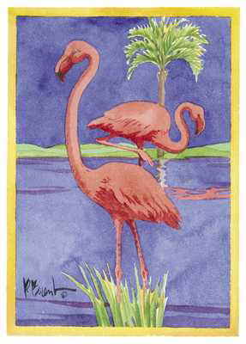

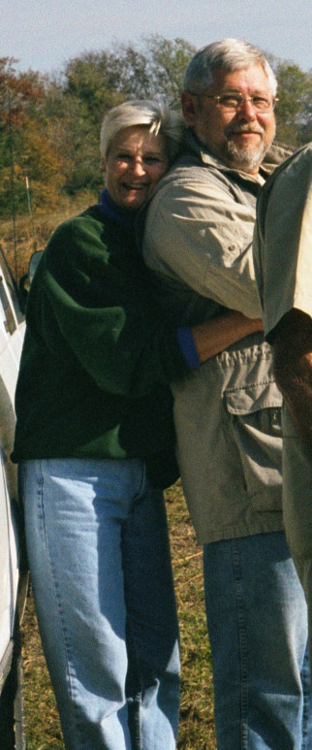

Farewell Friend…….

Ron & I met Millie last year at the ZNA Koi Show. She was a very kind and gentle person. She helped us to learn the ropes about the raffle and things that go into doing a koi show. She will be greatly missed! Ron and Mary Ann Bergman.

A poem for Millie
By: Khan Franklin

M is for the majority of those who knew her, loved her.

I is for the image she withheld to all of her students.

L is for the love she showed for her family.

L is for the lasting friendships she held so dear.

I is for her impartiality that showed toward all.

E is for her exhilarating personality, wit and charm.

Put them all together, they spell MILLIE the word that meant the world to so many.

We all know how she will be missed
By Bryan Bateman

When Bay and I joined MPKS, oh, I guess about 6 years ago, I remember going to the dinner meetings and seeing this crazy lady running around and making everybody laugh. She wanted to win the Koi pants so bad in the raffle that she could taste it - offered to trade anything for those Koi pants.

When she won them, she ran into the john and changed into them. I think she wore them to next six meetings. That was our first encounter with Millie. She taught me how to drink Merlot and Elize. She taught me how to say "Sahn-kay". And did she love those Kawarimono? Bob would roll his eyes whenever Millie started to talk about her beloved Matsukawabaki.

I'll always remember Millie for her energy, her love of life, her devotion to Bob, her smile, her laugh, and, of course, her koi pants.

Treasured Memories…

By Debbie Leschuck

Over the past few weeks we’ve all had to deal with loss of someone whom we have all grown to love and cherish. Some of us may have known Millie for a short time and some longer, but regardless of the length of time; she will always be part of our lives.

I’m writing this because during the mass, which was held for Millie the priest said something, that has stuck with me. He stated that Millie knew the meaning of life. She grabbed hold of it and lived every day to it’s fullest. He said that when she touched each and everyone one of us that we too were given the opportunity to grab onto life. Well I don’t know about you but I felt that that was a very true statement.

When Nick first started getting involved in koi keeping and pond filtration he kept trying to get me involved. I sort of stayed in the back wings for a long time. It was Millie who kept saying to Nick bring Debbie over or tell her to come to the meetings. Well as she kept on him and he did the same to me so finally I gave in. For this I’m grateful because it made me find a new friend.

When I met Millie she immediately took me under her wing and before you know it we started our friendship. When we would sit around our ponds Millie was always schooling me about koi. I would say, “Wow, look at the black on that fish”, she would ever so politely correct me and say, “ that’s called Sumi”. Or I would say, “That is really a pretty red”, again Mil would say, “That’s called Hi”. The best was when I was introduced to the sparkly kind. Which may I add I still refer to them as the sparkly kind. Millie laughed and explained the true meaning of “Gin Rin” however it took me a while to not pronounce “Gin” like the alcohol name of “Beefeater Gin”. But Millie was so great in her definitions that it didn’t make me feel stupid but what it did was hold my attention and make me want to ask questions. It’s no wonder why her students kept in touch even after they moved on. She was a great teacher and listener.

It was around 3 months after getting to know Millie and sitting around her pond at one of her and Bob’s many barbeques and actually finding out the price range that us crazy people as referred to as “Koi keepers” actually spend on fish. So I was bold and asked “How can you ladies stand the fact that your husbands spend so much money on fish?” Millie put her hand on mine and said “Girlfriend every time my husband spend money on a fish I just go and buy myself a piece of jewelry, that always seems to help.” Well that advice was taken seriously and now I justify the money going out on fish and don’t hesitate to buy myself something if I see it. Thanks Mil.

But as time and years went buy and we got to know each other even better Millie turned out not just to be an acquaintance through Koi but a true girlfriend and fish were second on our list of agenda’s and talks. She was the type of girlfriend that always made you feel important when you hit one of you low spots in life and she knew just what to do to make you smile. I could call her for anything and talk candid and know that it would never be shared and sometimes not even with our husbands.

Please bare with me on a few memories of Millie that I want to share they make me laugh when I recall them:

During construction in the Brudd’s household Nick and I spent a lot of time over they’re trying to help in any way that we can. One day Bob and Nick were lying done the plywood for Mil and Bob’s new kitchen floor. Millie and my jobs were to screw and secure this 4X6 piece of wood with screws every 2 inches or what seemed like every 2 inches. Well after about 2 pieces and hoping our batteries would run out on our cordless drills and endless chitchat. Out came the bottle of wine, which followed us from plywood sheet to plywood sheet. I came up with a great idea, why don’t we get a black mark and color circles on all these “x’s” where the screws are suppose to go? Well, Millie laughed and was seriously considering the suggestion until our husband’s overheard and said, “Don’t even think about it.”

You never left the Brudd house after a great visit empty handed. Millie always made sure she gave you something. Even if it was just leftovers from one of the many wonderful dinners that we shared. I remember talking about how I would probably never own a fur coat. Not because I don’t want one but because my height or shape would make me look silly in a fur coat. Millie did not take that for an excuse. So she jumps up and makes me follow her to her closet were she proceeds to take out her many furs some too outrageous but only Millie would wear and makes me play fashion show. Of course Millie found one those looked good on me and made me model for my husband who just shook his head and said to Millie “your going to get me in trouble.” The point to this memory is she knew exactly what to do to give me the encouragement and to never say never until you try.

Even though these are just a few treasured memories whenever my heart aches or the steps that I take seem heavy. All I do is think of the times that we laughed so hard and I once again feel warm and the bounce is put back into my steps. Thanks Millie for being there always and for giving me the opportunity to have such treasured and lovely memories, you were indeed a true friend.

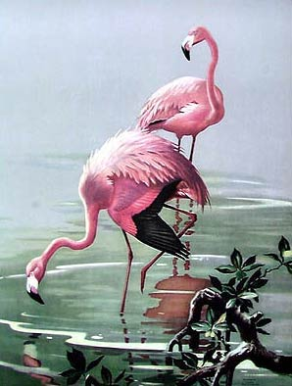

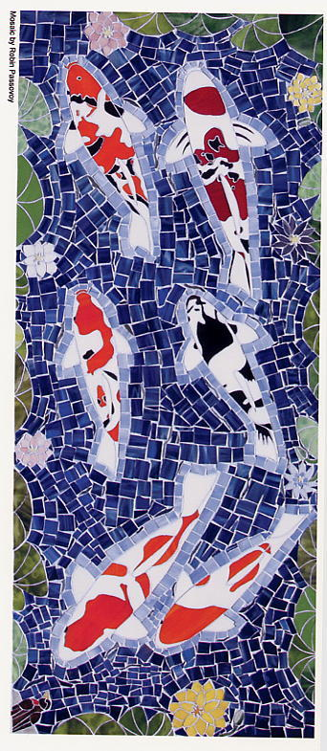
Robin Passovoy: Mosaic Art Glass Artist

By Millie Brudd
Northern Midwest ZNA
Photographs by Bob Brudd & Dr. Bob Passovoy

There is an unparalled fluidity in each piece of art glass mosaic that Chicago area artist Robin Passovoy creates. After years of perfecting her art and craft, Robin’s creative inspiration is now primarily derived from and dedicated to her passions and hobby- all things natural and nishikigoi.

Most recently, Robin has turned her attention and applied her art to capturing, in glass, the beauty of her own living jewels and those of hobbyists who commission her work. It is somehow befitting that the beauty of nishikigoi, with all of their iridescent qualities, be immortalized in the reflective qualities of mosaic art glass.

A graduate of Chicago’s Columbia College, Robin has long accepted the fact that she is a tactile person who needs to keep her hands busy. Possessing an affinity for art glass, Robin first began her cottage business making both general and commissioned pieces of jewelry. Her love of nature however soon carved a path that beckoned her to follow. “I was sitting at the pond’s edge relaxing and watching the koi when, at times, I would be almost blinded by the sun reflecting and bouncing back from gin scales-it was as though I was looking at natural blue mirrors.” Continuing to closely view the rhythms and motions of her koi, the application and direction that her art would follow became apparent as sketch after sketch revealed their purpose.

Even the most fluid and difficult of Robin’s compositions begin with sketches applied to dimensional boxes. Blocking square inches in this manner allow the artist to get a feel for the size relative to the whole. To an untrained eye, an early stage piece would probably resemble a random pattern of geometric ramblings but what is actually being created is the initial calibration of subject marrying form and function.

Robin’s best-known work is probably her series of ‘Best in Variety’ awards that have been custom crafted for presentation by both the Mid Atlantic Koi Club and the Midwest Pond and Koi Society. These 8x10 art glass mosaics replicate, in intricate detail, the variety to which the award is presented and are highly coveted by fortunate award winners.

Her largest outdoor art glass mosaic piece to date is an overall 10’x 3’ triptych commissioned as a decorative piece for decking surrounding a koi pond. The center 6-foot panel contains a variety of nishikigoi from the hobbyist’s collection; one side 2-foot panel depicts the ZNA logo and the other 2-foot panel contains shadowy Japanese plum blossoms positioned in front of a full spring moon. Her artistic signature, a demure red-breasted robin, sits almost invisibly in a bottom corner.

Robin’s most ambitious glass mosaic project is a very reflective, highly creative bathroom that replicates a watery barrier reef.
The art glass mosaics by Robin Passovoy can be seen at a variety of koi club related trade shows and on trophy tables around the country. She can share her artistic portfolio and collaborate on commission inquiries via e-mail at: bluespanch@yahoo.com.

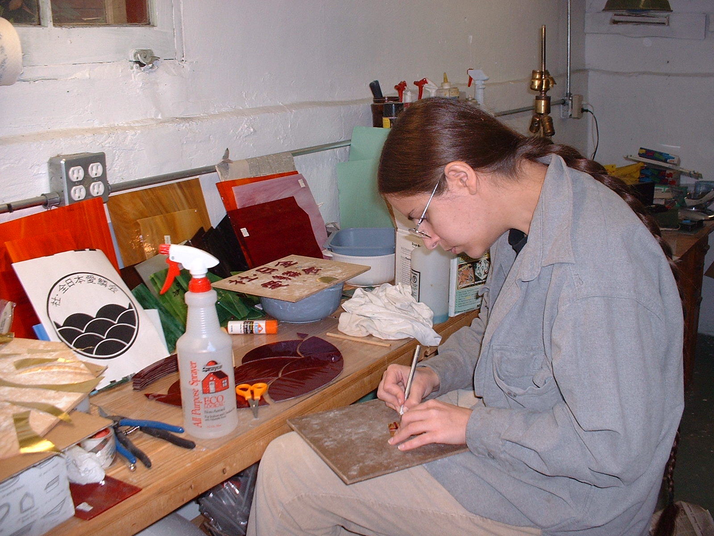
Robin Passovoy at work

Eulogy about Dr. Kuroki
by Jim Reilly
The koi world received sad news this past week with the announcement that Dr. Takeo Kuroki, founder of Zen Nippon Airinkai, had passed away.
Dr Kuroki was a fascinating and highly accomplished individual. His life was marked by one of great energy, deep artist talents and a profound love of nature.
As a young boy growing up in a rural setting outside of Miyakonojo, Japan, Kuroki was very familiar with the releasing of carp in the rice ponds each spring. His grandfather taught him at this early age how to feed, net and harvest this important food source. So it was quite a natural evolution for the young Takeo to merge this past, along with his love of art, into a deep interest and love of Nishikigoi.
Good koi keeping techniques were had to come by in the 1950s so Kuroki worked hard to improve his skills. By 1962 he had succeeded by raising a Shiro utsuri that took first place in the Shimonoseki City koi show.
As a result of this show, Dr Kuroki and others formed the Oita district koi fanciers' association. And Dr Kuroki became the first president of this 200-member organization. In 1965 he formed the Western Japan koi fanciers' association. The first show was held in 1966 and Dr Kuroki won the prestigious Prime Minister's cup and overall winner trophy of that event.
In 1968, the All Japan koi fanciers' association was established and Dr. Kuroki was elected President once again. This organization in turn, became the modern ZNA association that many of us belong to today.
These experiences lead Dr Kuroki to a lifetime commitment to the art of koi and a deep desire to spread this wonderful hobby all over the world. In pursuit of that goal, Dr Kuroki wrote the first all important primer books on Nishikigoi entitled, Manual of Nishikigoi and Modern Nishikigoi. He also served as the editor of Rinko magazine in it's early years. But with all these public accomplishments and winning show koi, Dr Kuroki remained a humble and quite individual. The koi and his home pond remained as a place for quite mediation and reflection after the demands of his medical practice and hospital administration duties.
As a skilled plastic surgeon, university lecturer and hospital administrator, Dr Kuroki showed a great love of life, learning and science. But many were surprised to find he was also a published poet! Publishing simple but incredibly beautiful haiku (Japanese poetry) under the pen name Junkei, Nishikigoi were often his focus.
He was able to incorporate the essence of koi a few simple lines---
Green Shadows deepen
Wavelets ripple the surface
Below, koi shimmer
Indeed, when I heard news of his passing I spent some quite time along side of my own pond and remembered his words about koi in the spring-
Snow at the edges
Of a new spring, young green trees
Koi --- bright, fresh and
Quick
May he live in our memories forever.
Editor’s Notes

We have enclosed many items for the club to review in this month’s mailer of the newsletter. At our next meeting Bob Brudd will have many items that he will try to cover. The most important one is the presenting of our by-laws. Please try to review these prior to the meeting so that Bob has the chance to floor all discussions in a timely fashion. I have also attached to the by-laws a cover page that you may use as a worksheet to write down something that you may not understand or would like a better definition on or maybe a suggestion, etc. You can either mail these directly to Bob Brudd or bring them along to the meeting.

Also enclosed is the 2003 Koi Show Packets. If time allows we will try to cover some of this. Otherwise Nick, myself, and Bob will be gathering up the troops shortly. This year we would like to draft committees to handle certain events, task and show planning. Please feel free to think about where and when you can help in donating your time and creativity. We will hand out committee sign up sheets at the meeting and will also try to briefly cover this. As we all know time flies by so fast and our Koi Show is just around the corner.

Please feel free to call us anytime or write down something that you would like to see different or felt we may have missed at last years show. This is a club effort and we all know that without all of you our show wouldn’t have been a huge success last year. So please sign up and join us in the fun and excitement of planning our next Koi Show.

Calendar of Events

June 21st Next Meeting
Site: To be announced

September 5th, 6th & 7th Koi Show

(This space is also available for advertising)

© By the Northern Midwest ZNA. Reprints only with the written permission of the NMZNA

